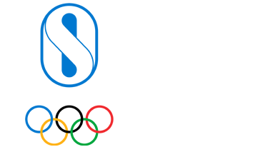

Application Details

Programme Selection

Category
World Programmes
Programme Cluster / Continent
Sport Development

Programme
Youth Athlete Development - YOG Qualification

Quad/Games Edition
Winter (Gangwon 2024)

Detailed breakdown of budget requested from Olympic Solidarity
Description
Amount (USD)
None
None

Programme (Long Form)
Youth Athlete Development - YOG Qualification

Programme Help/Instructional Text
Please complete your application with all the YOG qualification events for which your NOC wishes to receive support, bearing in mind the maximum budget available is USD 30,000. One application may be submitted per YOG edition.

Youth Olympic Games Qualification Details
Qualification Event
Total number of athletes foreseen to participate in qualification events
None
None
Sports in which you intend to send athletes in qualification events

None

Budget Proposal

Files/Uploads/Related Documents
Total budget requested (USD)

None
Request 75% advance payment

None
Other File Uploads

Please upload any other document you wish to share with Olympic Solidarity
File Notes
None
None

